1. CREATE DATABASE library;

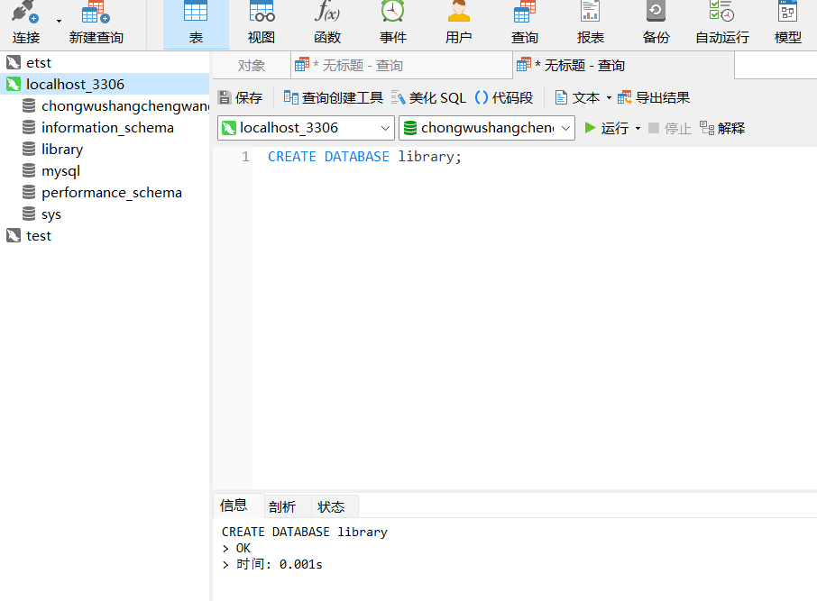

2.

2.

USE library;

CREATE TABLE books (

book_id INT AUTO_INCREMENT PRIMARY KEY,

title VARCHAR(100) NOT NULL,

author VARCHAR(50),

publish_date DATE

);

